using marmoset to practice coding

# introduction

The Marmoset system is an automated code test system. You can use it to check the correctness of your code when solving practice problems.

# first submission challenge

Create a C++ program to output “Hello World!”.

Name the file hello_world.cpp.

Submit your code to the Marmoset code testing server for grading.

# accessing marmoset

To access the Marmoset system, point your web browser to <http://marmosetme.uwaterloo.ca>. You will be required to sign in to the University of Waterloo Central Authentication Service.

Once logged in, you should see a screen similar to the following. Click the “Authenticate as…” button.

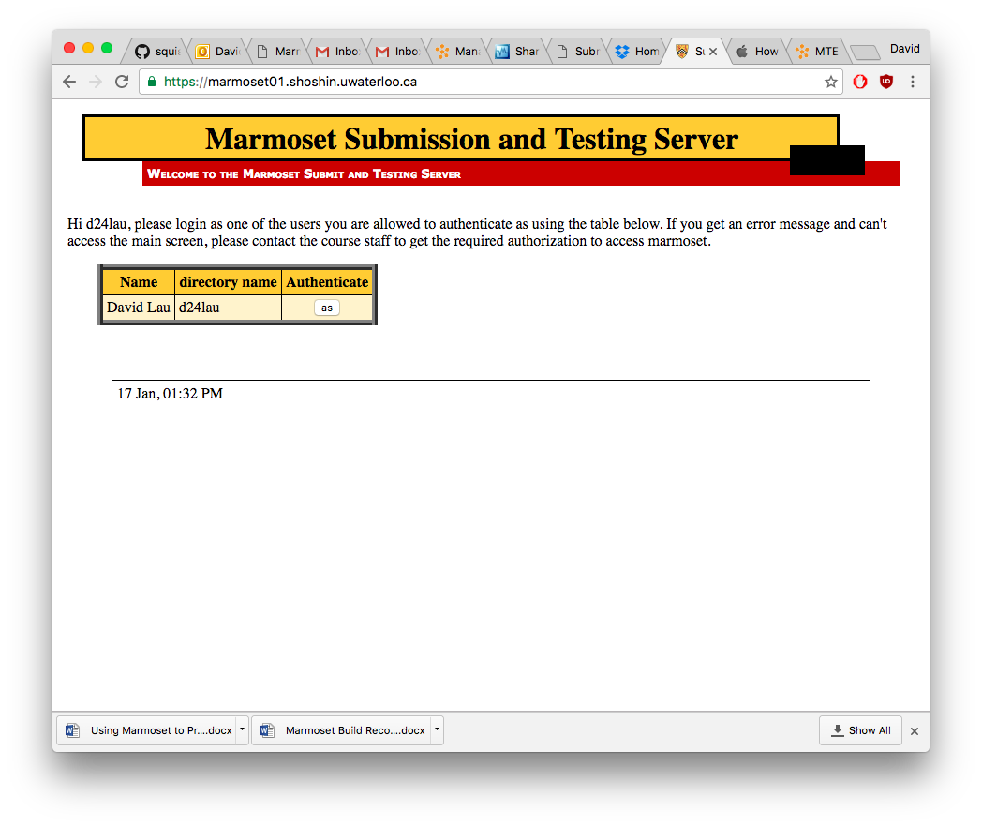

You should see a page showing the available projects:

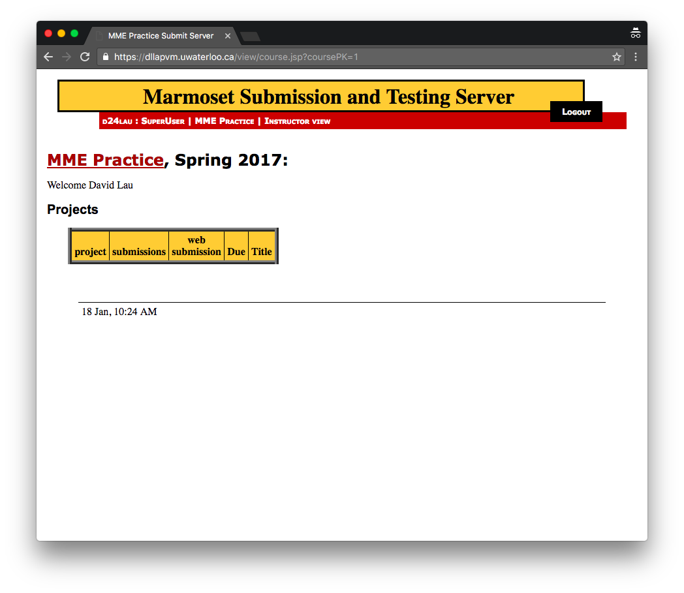

# Submitting code for grading

From the table of projects, click the ‘submit’ link for the project ‘First Submission’.

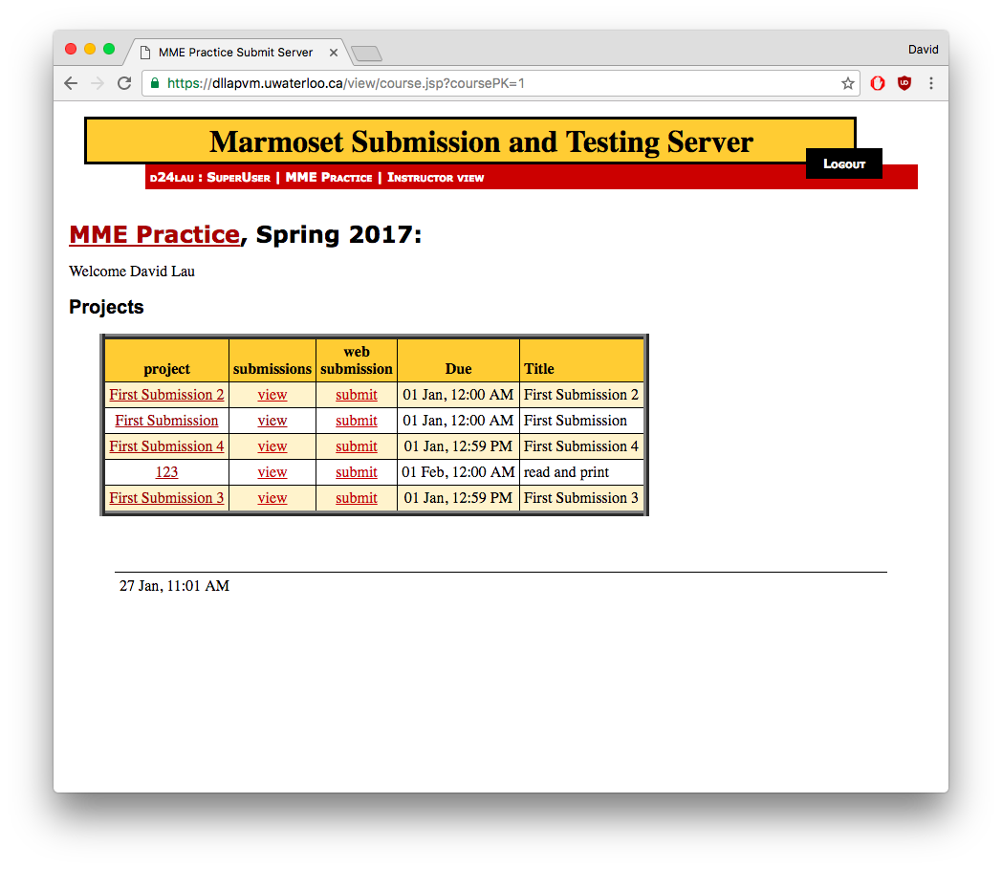

Click the ‘Choose File’ button and then select your cpp file.

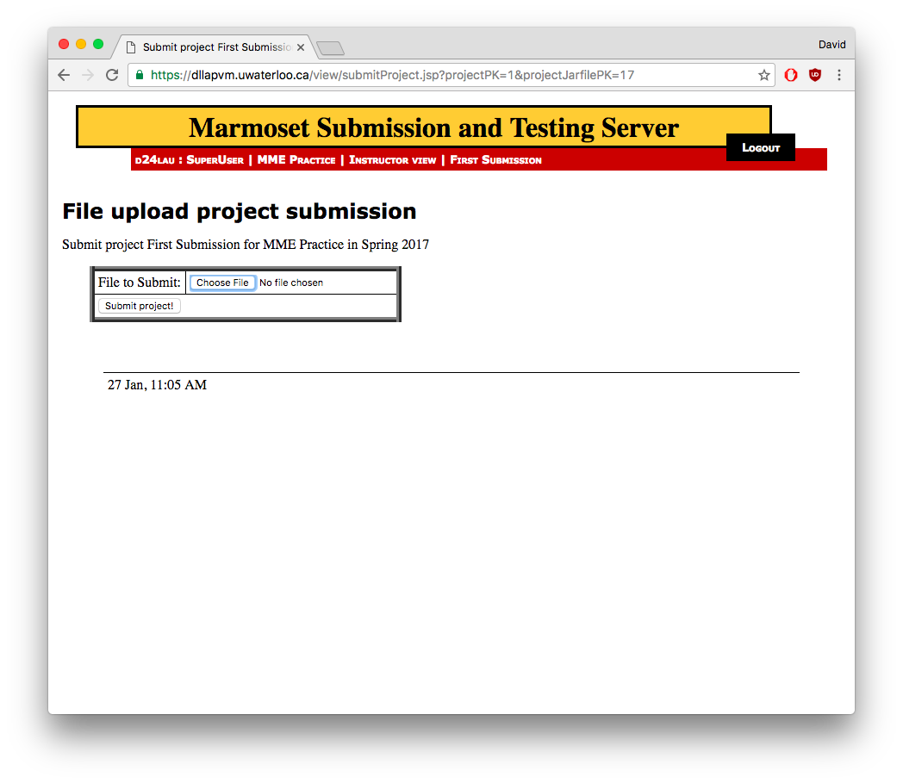

Click the ‘Submit project!’ button.

# Checking results

Upon successful submission of your code, you will find your submission listed on the Submissions table. The ‘public test score’ and ‘detailed test results’ fields will be shown as ‘not tested yet’.

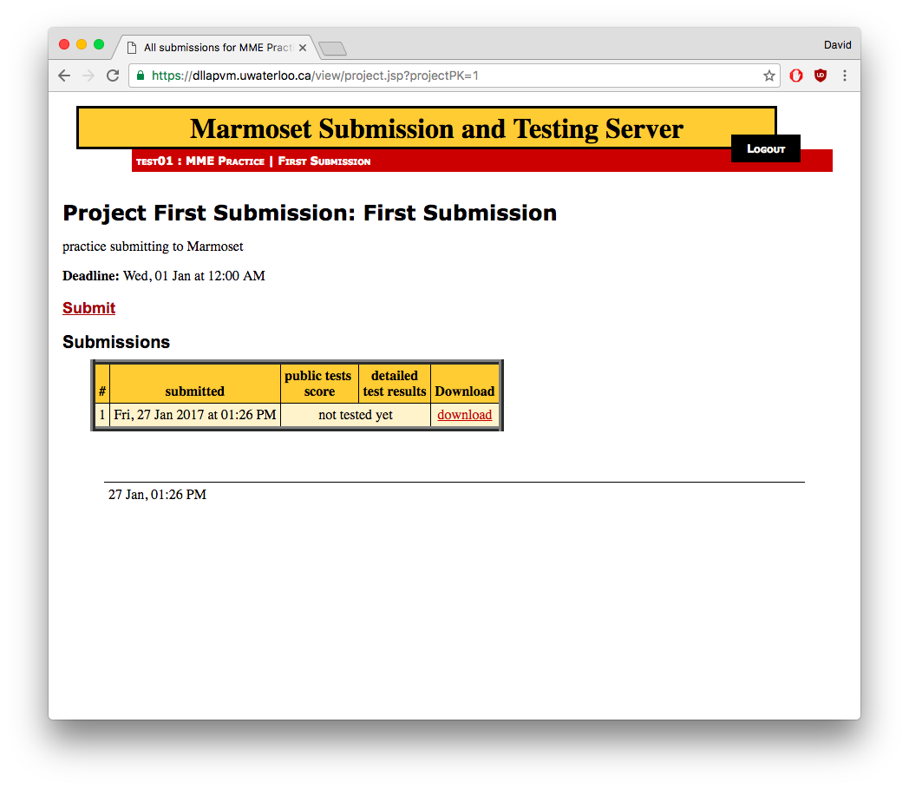

It can take 2 to 10 minutes for your code to be tested. When more students are submitting code simultaneously, response times will be longer.

Periodically refresh the web page to check if your code has been tested yet. Once the server has successfully run your code, you will see a score and a link to view details of the test results.

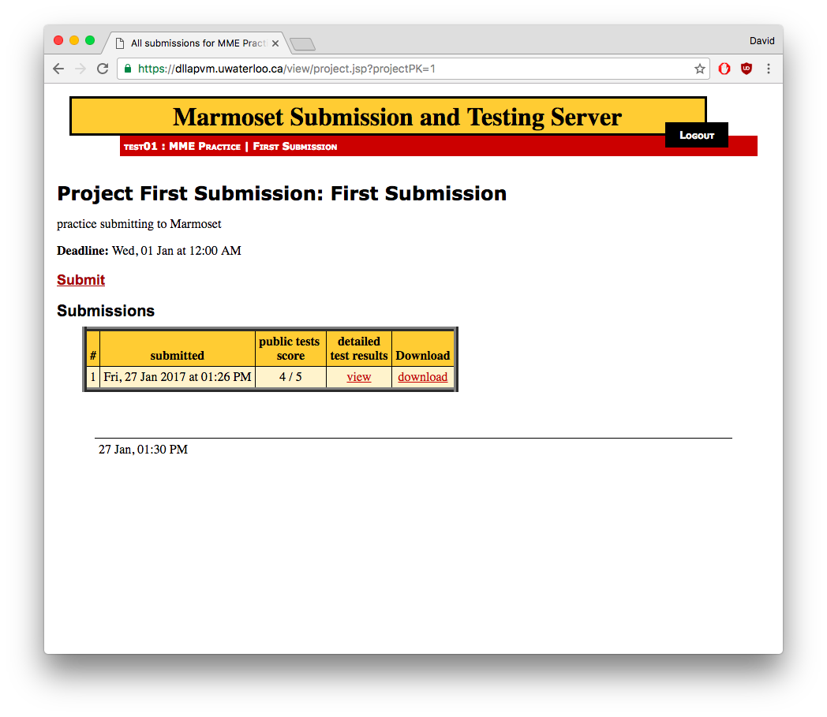

# test results

When you click the ‘view’ link under ‘detailed test results’, you will see test results for individual test cases.

The ‘name’ column can give you some information about what the test case was looking for. The ‘long result’ column will often contain information about the specific output from your program when it was run. This information is often helpful in troubleshooting or debugging your program.

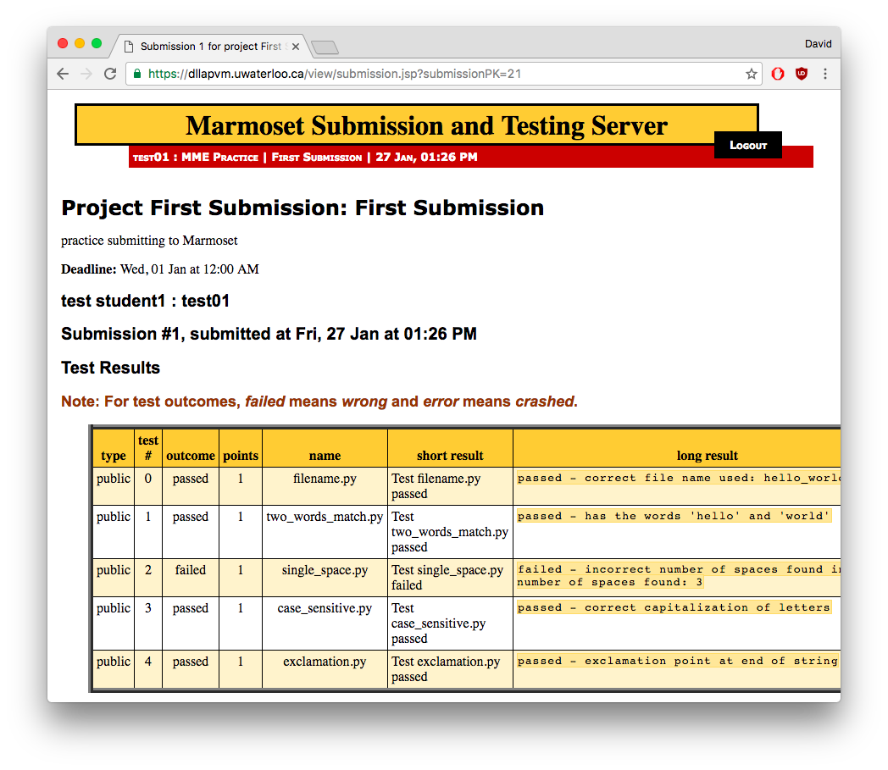

# incorrect file names

Marmoset requires that the file name for your code exactly match its specified file name, including case sensitivity. If your code file name does not match exactly (in this case hello_world.cpp), Marmoset will be unable to compile, run, and test your code.

If your file name does not match, the test details error message will look something like the following:

